1. Let’s see how to resolve the same request mapping at two different places.
   1. 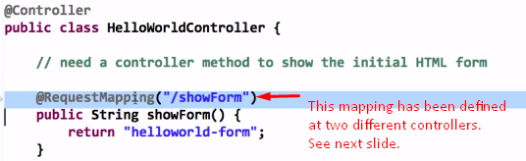
   2. 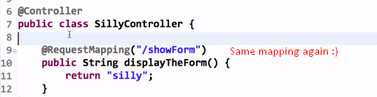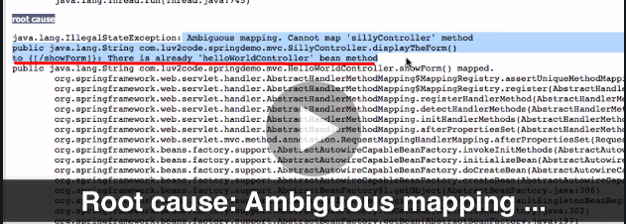
   3. 